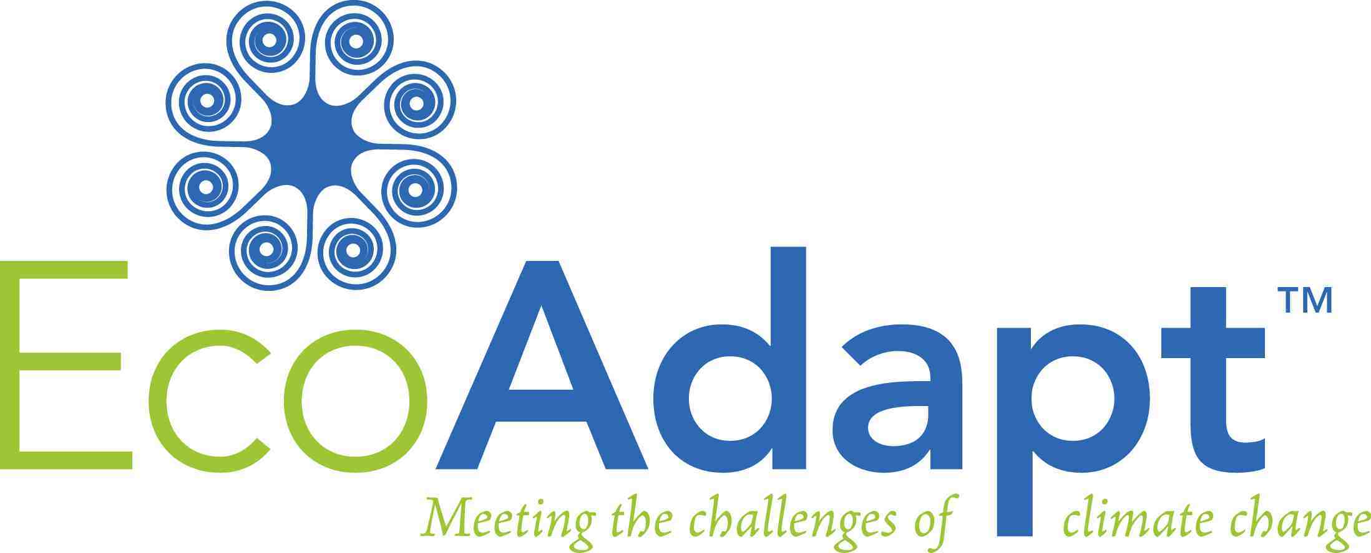
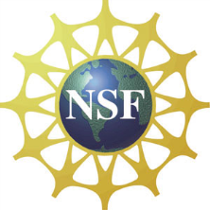

Climate Adaptation Options for Natural Resource Managers

in the Sierra Nevada

May 27, 2014 10am – 4pm

Location: University of California, Fresno Center, 550 E. Shaw Ave., Fresno, CA

Workshop Objectives:

Present maps of climate change refugia and connectivity of meadows across the Sierra Nevada.

Present findings from Sierra Nevada vulnerability assessment and adaptation strategy project.

Evaluate potential vulnerabilities of management goals by using Sierra Nevada vulnerability assessment findings.

Brainstorm opportunities to incorporate adaptation strategies into local and regional planning and management activities, and/or to reduce vulnerabilities of management goals.

Collaboratively identify climate adaptation options for conserving montane meadows.

Provide climate change adaptation training and tools to extend this process to similar efforts in participants’ own work.

Schedule:
10:00-10:15 Welcome and Introductions by Dr. Toni Lyn Morelli, Northeast Climate Science Center and Jessi Kershner, EcoAdapt
10:15-11:00 Presentation on Vulnerability and Adaptation in the Sierra Nevada by Jessi
11:00-12:00 Presentation on Sierra Nevada Meadow Refugia and Connectivity by Dr. Sean Maher, Postdoctoral Researcher at U.C. Berkeley, and Toni Lyn
12:00-1:00 Lunch (provided)
1:00-2:30 Group activity: Applying vulnerability and adaptation information in management decision-making
2:30-3:00 Report out and group discussion
3:00-3:30 Wrap-up

