The California Environmental Change Network
Business Plan and Strategy

Prepared by:

Sam Veloz, Thomas Gardali, Deanne DiPietro, Nadav Nur, Grant Ballard
PRBO Conservation Science, 3820 Cypress Drive #11, Petaluma, CA 94954

D R A F T O U T L I N E
26 July 2012

Prepared for: The California Landscape Conservation Cooperative

Acknowledgments

Executive Summary

- Introduction
The scale and pace of anthropogenic pressures on natural systems requires monitoring to detect and attribute the effects of environmental change. The uncertainty of predicting impacts of change indicates we cannot rely on models alone, but must invest in monitoring programs. [Etc.]

- The California Environmental Change Network

  - General Description of the CA ECN. The CA ECN is an integrated, multidisciplinary network of long-term monitoring stations that gather and share information using standardized protocols. Monitoring locations have been identified and prioritized where the greatest changes in climate and bird communities are predicted to occur and overlaid with locations of field stations, reserves, refuges, and XXX. [brief overview of measurements, data management, and links to other systems, etc.]

  - Goal & Objectives. The goal of the California Environmental Change Network is to guide and prioritize conservation activities that benefit biodiversity while conserving ecosystems and ecosystem services.

- Specific CA ECN objectives include:
  - Establish and maintain a network of sites covering all of California to obtain comparable long-term datasets monitoring a range of common variables of major environmental importance.
  - Provide for the integration and analysis of these data, to identify environmental changes and improve understanding of the causes of change.
  - Distinguish short-term fluctuations from long-term trends, and predict future changes.
  - Develop and disseminate natural resource management recommendations to public and private interests.

  - Users and Planned Uses of CA ECN Outputs [table of potential users and likely uses]
  - Benefits of the CA ECN [Science, Policy and Planning, Resource Management, others?]
  - When Will Benefits be Realized? [table/timeline (by year) of things like available models outputs, weather data live, reporting, etc. This section will show that even though this is a long-term commitment, useful products will be available from year 1]
  - Relationship to Other Monitoring Efforts [use examples such as Neon as larger scale and Pepperwood/Sonoma Co as smaller scale to illustrate a gap at the scale we propose, show measurement complementarity]
  - Why Implement the CA ECN Now? [bulleted list of reasons from the proposal and things such as information gap, known synergies, adaptive conservation planning, etc.]

- Development of the CA ECN

  - Study Site Selection
    - Power
  - Priority Measurements [how we came up with them plus table of category, measurement, reasoning, method, frequency]
  - Protocols [brief information on likely existing protocols, key resources, etc. This will not be the actual highly detailed set of protocols]
  - Data Management [includes information on curation, discovery, delivery, and analysis]

- Estimated Costs of Implementation
  - Assumptions
  - Methods for arriving at costs
  - Start up and ongoing costs

- Governance and Organization Structure
[Brief suggestion for how/who might govern the ECN]

Figure 1. Simplified example of an organizational structure for the CA Environmental Change Network.
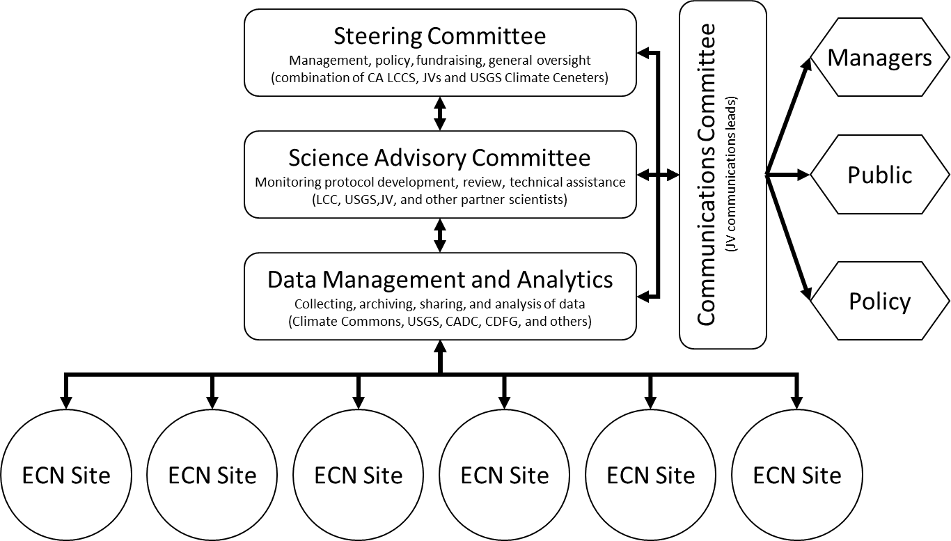

- Literature Cited

